Assignment (Prebuild Design Patterns)

1. **Write an object oriented code to implement Prime number class.**

**Implement a Prime class which should have following functionality:**

**- Ability to test if a number is prime or not**

**- Generate prime numbers**

**- Generate prime numbers greater than a number N**

**- Generate prime numbers less than a number N**

**- Generate all prime numbers between N, to M**

**- implement __len__() to tell number of primes between N and M where N < M**

**- overload +, += operators to nerate number prime number with respect to current prime number e.g.**

**>> p = Prime(3)**

**>> p + 1**

**5**

**>> p + 2**

**7**

**>> p += 3**

**>> p**

**Prime(11)**

**implement `__repr__()` and `__str__() methods**

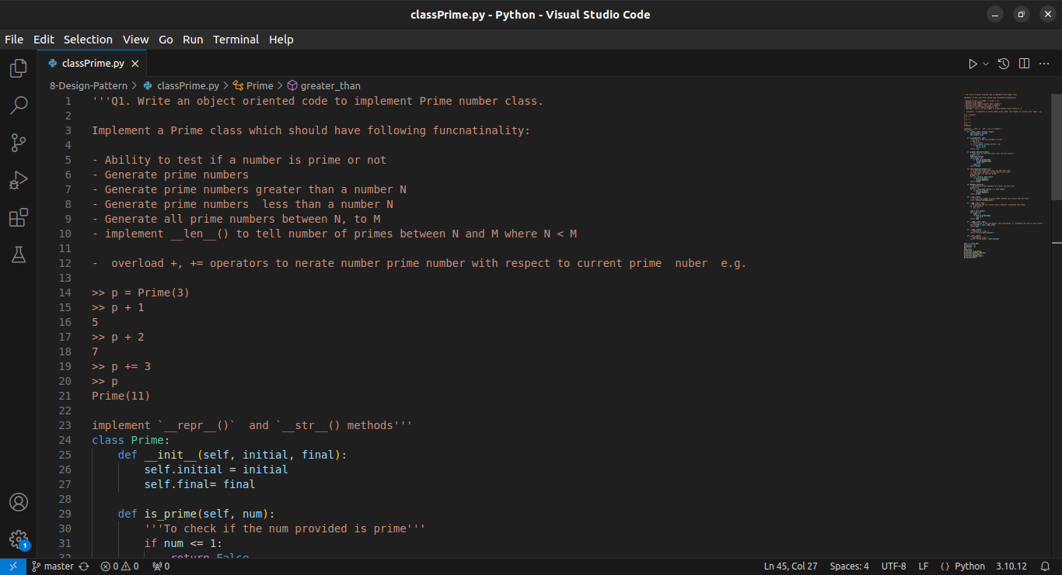

Code 1/4

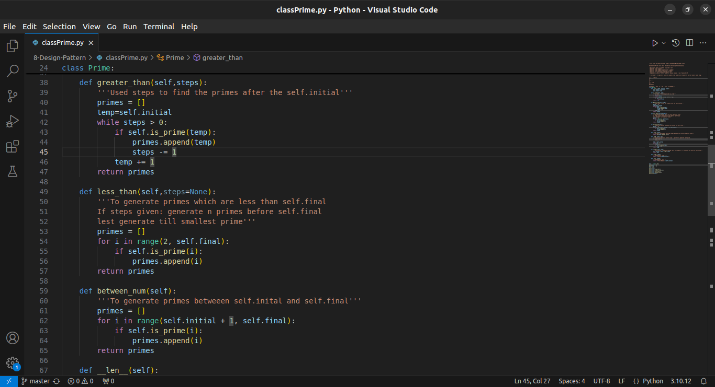

Code 2/4

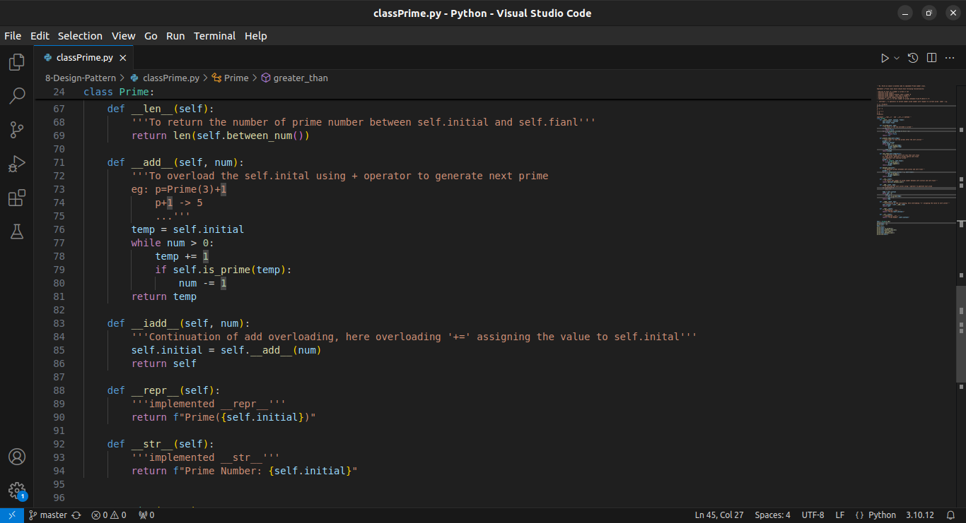

Code 3/4

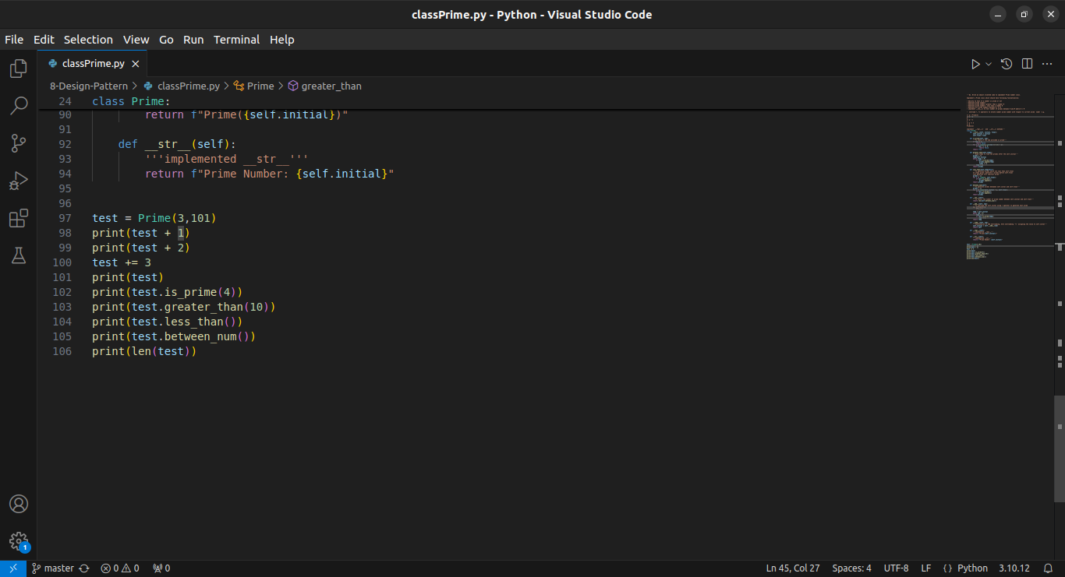

Code 4/4

**Input**

test = Prime(3,101)

print(test + 1)

print(test + 2)

test += 3

print(test)

print(test.is_prime(4))

print(test.greater_than(10))

print(test.less_than())

print(test.between_num())

print(len(test))

**Output**

